Becoming Catholic at Christ the King
Beth Hoskins, a marketing professional and mother of two, spent many years as a “Half-lic,” married to her Catholic husband and being exposed to the faith, but never fully committing to becoming Catholic herself. It was always something she considered, though. Her son’s experience transferring to Cardinal Pacelli made the difference. “When I saw how kind and welcoming the other students were, and the way they accepted Will, I realized this was a good place. As we attended Masses, there was a palpable sense of warmth at Christ the King. I was enjoying the homilies and the beautiful church felt like a place I could call home.”
Beth spent the better part of 2020 participating in the RCIA process, which she said was a great opportunity to learn about the fundamentals of the Catholic faith as an adult. “I’m glad I did it. I got to know the church leaders personally, and it was inspiring to see how others responded to the journey of becoming Catholic.” For her, the greatest gift of RCIA was knowing that she was joining a welcoming parish. “Scott Kroencke, our leader, told us parishioners were praying for us, and I could sense the warmth and acceptance in the community.”
Beth is grateful for her experience in RCIA. “I didn’t realize when I started RCIA that it is for people who are curious about the faith. The leaders want you to really learn about Catholicism before you decide.”

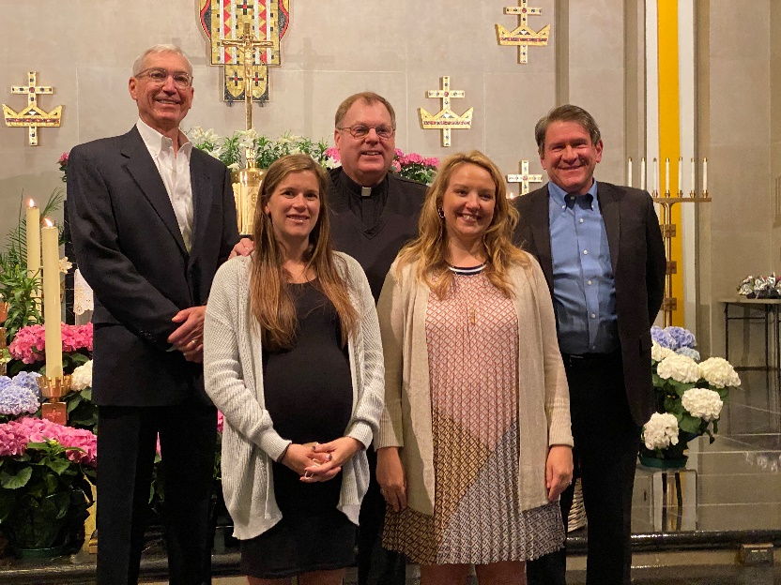
Beth Hoskins is pictured in the front right.

