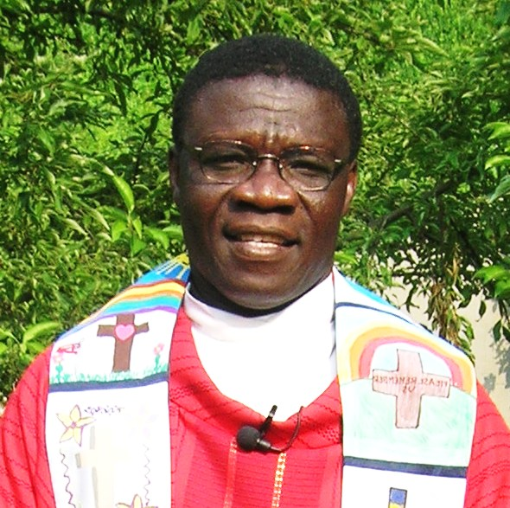
Does providing a YEAR of health care for a child or family speak to your heart?

In 2010 the Twinning Committee began a pilot project to provide health care in Ghana for needy families in the Diocese of Obuasi using Father John Agyekum’s parishes. Our intention was to fill a critical need of the people in Ghana .

Imagine providing health care coverage that includes out-patient services, in-patient services, oral health, maternity care, emergencies, etc. all for the low cost of $20 per adult and $7 per dependent child PER YEAR!! We know this sounds too good to be true, however, we assure you it is true. Prior to the enactment of the National Health Insurance Act in 2003 people were asked to pay “before” a doctor saw them, and not just for emergencies but EVERY point of service. It was known as the “Cash and Carry” system. This still holds true for those not able to pay into the plan.

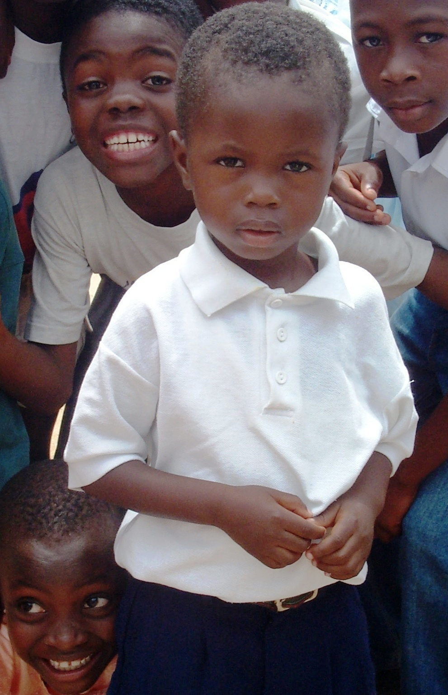
Today the most popular category of health insurance in Ghana, and the one that we support, is the district mutual health insurance plan/public health care. This plan is “operational” in every district in Ghana. Apart from premiums paid by members, the district receives regular funding from the central government. Every Ghanaian worker pays 2 ½ percent of social security contributions into the fund and a VAT, value added tax, rate in Ghana also has a 2 ½ percentage component that goes into the fund. Each resident is eligible (for coverage) under this plan regardless of prior health condition. After registering there is a two month administrative processing period. Certainly, there is a real need for this type of insurance to become accessible to the people who are too poor to pay the insurance premiums. Presently only 54% of Ghanaians are registered. In the first year of our project (2010– 2011), thanks to your generosity, we were able to provide health care insurance for 473 individuals. In 2023, thanks to our parishioners and the profits of our Fair Trade sales, we sponsored 45 children, 28 adults, and 118 families for a grand total of 545 individuals! The total amount donated was $7,252.

Because enrollment is a lengthy process, dependent in part on road conditions during the rainy season, we need to begin renewing current enrollees for (2025-2026) as well as enroll those on the waiting list. Please indicate your willingness to renew/begin sponsorship.

($7 per dependent child, $20 per adult, $54 parents and two children) make checks payable to Christ the King and note For Health Care Project. You may also donate electronically at www.olctk.org. Just
click on Online Giving via We Share.

Name__________________________________________________________________________________
Address________________________________________________________________________________
Telephone_____________________________________________________________________________
Email__________________________________________________________________________________
I would like to sponsor #____Child(ren) #____ Adults #_____ Parents & Two Children.
Enclosed $___________________________________________
I am a new/renewing sponsor. (please circle)
Return the above form with your check to the Parish Office or in the Sunday collection basket. Thank you!
Contact person: Joan Hilton at hilton_joan @yahoo.com or 871-9251.

